Author: Zachary Thomas

[Email address]

Abstract

[Draw your reader in with an engaging abstract. It is typically a short summary of the document.   
When you’re ready to add your content, just click here and start typing.]

Oceanside worship center finance application

Table of Contents

**No table of contents entries found.**

# Introduction

The Church Finance App is a windows application designed to store financial data, generate reports, reconcile data, and provide traceability between financial transactions. The application serves as an interface between the user and a SQLite database that holds the financial data. The application also gives flexibility to the user to create and manage budgets, set reminders for reoccurring bills.

# Architecture

OWCFA is a windows application written in Java using Swing for the GUI development. It encapsulates a model, view, and controller (MVC) architecture. The database is a SQL. All information is read from and written to these tables of the database. This is the model. The views are the dialogs that the users interface with. These are discussed in detail in the design section. The controller is a software component of the application that acts as a broker. The broker knows how to process requests that the viewers create (via user input) and retrieve or send that information to the database. The architecture can be seen in figure 1 below.

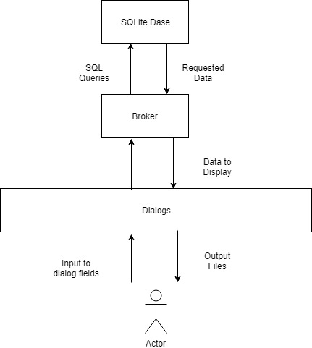

Figure 1- Software Architecture

## Database

An SQL database is used maintain all of the data. Using an SQL database allows for the application to have scalability to be used locally or accessed remotely depending on the location of the database. The database will contain 4 tables with a fixed number of columns. Tables 1-4 show the name, description, columns, and data types for each table of the database.



Table 1- Offerings Table

# Design

## Entry Dialog

## Offerings Dialog

## Purchase Dialog

## Transfers Dialog

## Ledger View Dialog

## Report Creation Dialog

## Upload Document Dialog

## Contribution Statement Dialog

## Visitor and Members Dialog

## Errors

## s

## Dialogs

The church has one checking account and one savings account in which all auxiliaries keep their money. Following this structure, the software wi

How to use